EXPT NO:4 | Visual encoding of data
Roll No 23BAD079 | Visual encoding of data
DATE: 20.01.2026 | Visual encoding of data

PRE-LAB QUESTIONS
- How does the human visual system process visual variables?

Answer: The human visual system quickly interprets visual variables such as position, colour, size, and shape to recognize patterns and differences.

- Why is improper encoding misleading in analytics?

Answer: Improper encoding can distort data representation, leading to incorrect interpretation and wrong conclusions.

- What are perceptual limitations in visualization?

Answer: Perceptual limitations include difficulty in accurately judging colour intensity, area, and overlapping visual elements.

- How does colour choice affect interpretation?

Answer: Colour choice influences attention and meaning, and poor colour selection can confuse or mislead viewers.

- Why should AI dashboards be perceptually optimized?

Answer: AI dashboards should be perceptually optimized to ensure information is easily understood, accurately interpreted, and supports effective decision-making.

OBJECTIVE: To apply effective visual encoding principles for meaningful data communication.
SCENARIO: A city traffic department analyzes accident data to identify high-risk zones and accident severity patterns.
IN-LAB TASKS (Using R Language) • Encode severity using color gradients • Represent accident frequency using size • Use shape to indicate accident type

Code:
print(“Roll No.23BAD079”)
library(ggplot2)
traffic_data$Location <- as.factor(traffic_data$Location)
traffic_data$Accident_Type <- as.factor(traffic_data$Accident_Type)
traffic_data$Severity <- as.factor(traffic_data$Severity)
ggplot(traffic_data, aes(
x = Location,
y = Casualties,
color = Severity, # color → severity
size = Vehicles_Involved, # size → accident frequency/impact
shape = Accident_Type # shape → accident type
)) +
geom_point(alpha = 0.8) +
scale_color_brewer(palette = "Reds") +
labs(
title = "Traffic Accident Severity Analysis",
x = "Accident Location",
y = "Number of Casualties",
color = "Severity",
size = "Vehicles Involved",
shape = "Accident Type"
) +
theme_minimal() +
theme(axis.text.x = element_text(angle = 45, hjust = 1)) 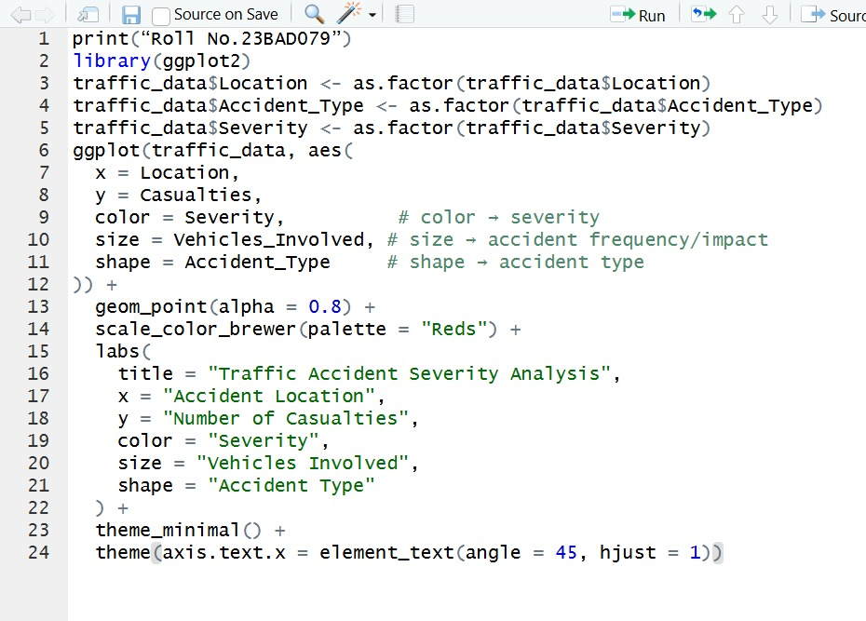

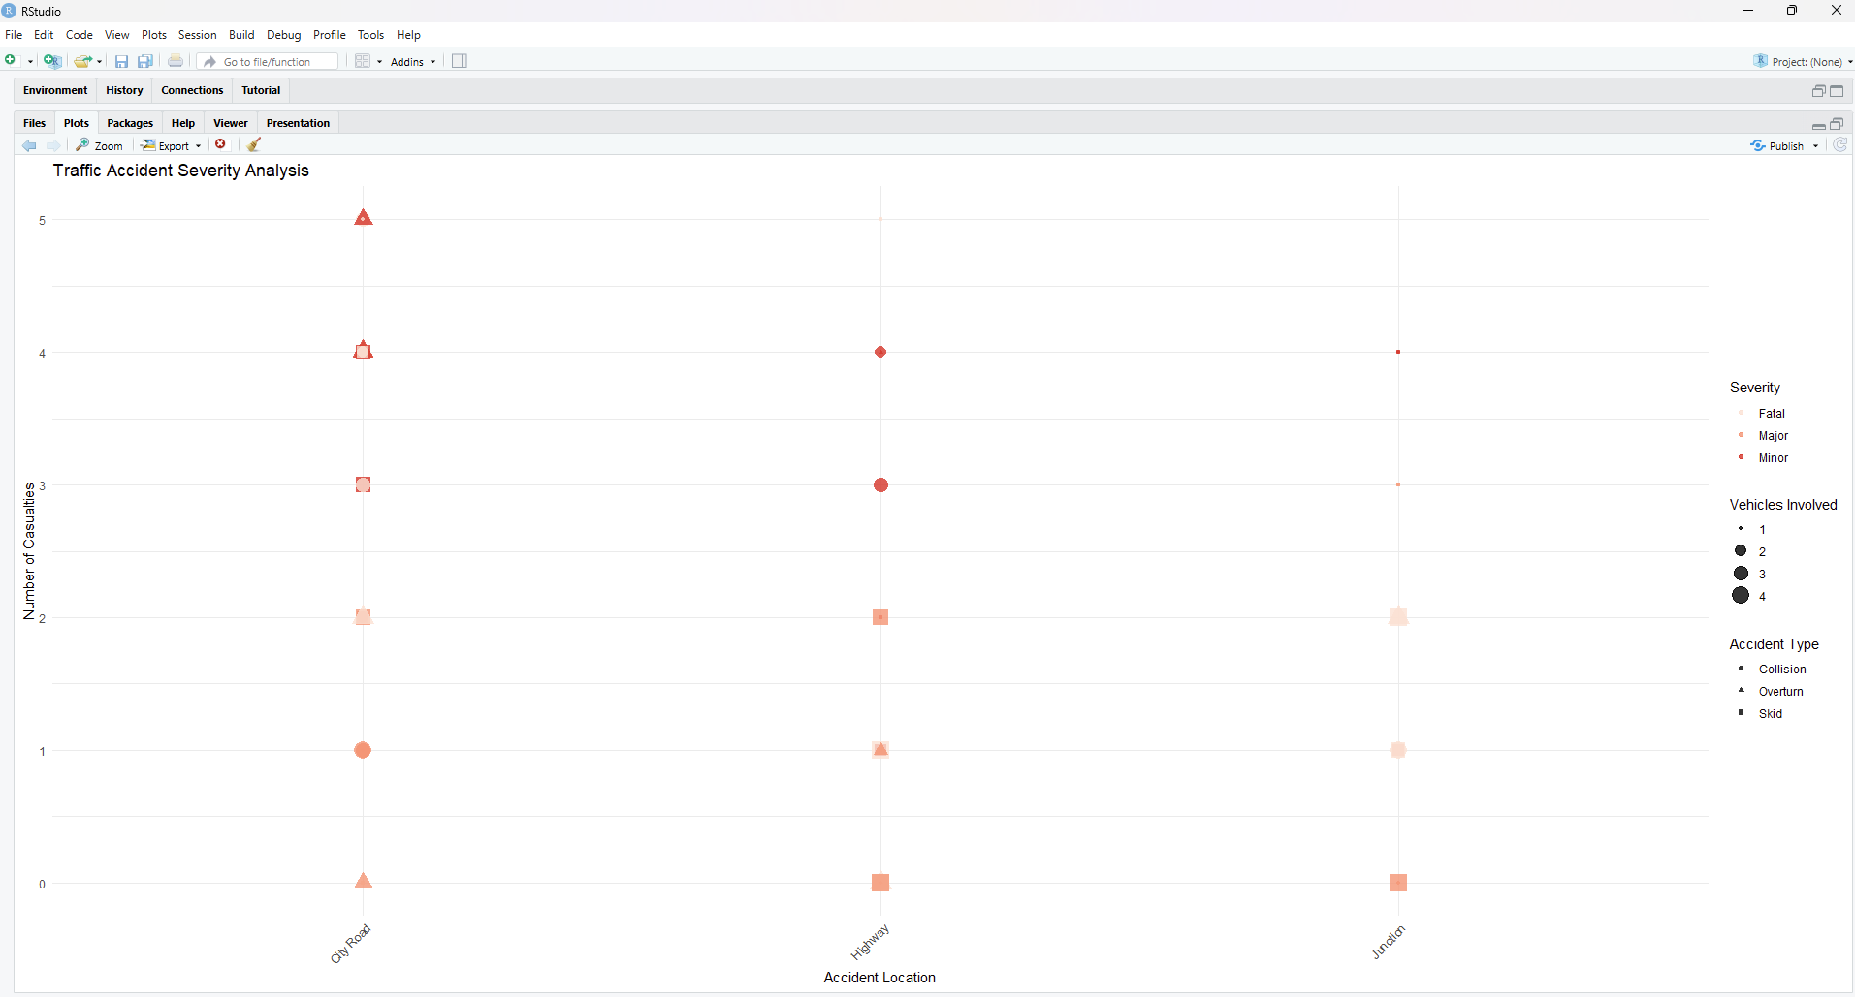

POST-LAB QUESTIONS
- Which visual variable best conveys severity and why?

Answer: Colour is the best visual variable for severity because differences in color intensity are quickly perceived and easily distinguish levels of seriousness.

- How can poor encoding mislead policy decisions?

Answer: Poor encoding can hide critical patterns or exaggerate trends, leading to incorrect interpretations and wrong policy decisions.

- What precautions should be taken for colour-blind users?

Answer: Use colour-blind-friendly palettes, sufficient contrast, and combine color with other encodings like size or shape.

- How does visual encoding affect AI explainability?

Answer: Clear visual encoding helps users understand AI outputs and reasoning, improving transparency and trust in AI systems.

- Suggest improvements for large-scale public dashboards.

Answer: Use simple layouts, interactive filters, clear legends, and optimized visual encodings to ensure readability and usability at scale.

LEARNING OUTCOME: Students learn perceptually effective visual communication for AI systems.

ASSESSMENT
Description | Max Marks | Marks Awarded
Pre Lab Exercise | 5
In Lab Exercise | 10
Post Lab Exercise | 5
Viva | 10
Total | 30
Faculty Signature

